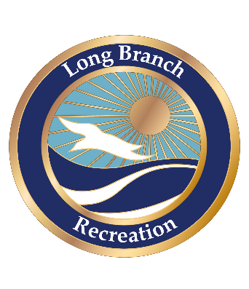

City of Long Branch, Municipal Building, 344 Broadway, Long Branch, NJ 07740 (732-571-6545)
Long Branch Department of Recreation Park & Field
Permit Application
(Information must be printed legibly and complete; otherwise application will be returned or denied)

Contact/Applicant_________________________________________ Phone #________________________
Organization______________________________________________________ Date _________________
Address_______________________________________________________________________________
Park and field requested__________________________________________________________________
Dates Requested_________________________________ Times requested_________________________
Type of activity__________________________________________________________________________
Are you charging a fee? If so, how much per participant/player/team/league? ________________________
Anticipated number of participant/player attendance during activity _________________________________
How many spectators do you anticipate attending? _________________________________
Will you be hiring a licensed professional security company to develop and manage your event’s security plan? YES NO
Do you have an athletic trainer on staff for the games? YES NO
Copy of blank waiver and release of liability form(s) for athletic participants attached. (Release of the City of Long Branch from
liability must be included on the form)
Will you require Long Branch Police Officers to be present for security and/or traffic control? YES NO

Park & Ball Fields Rules and Regulations

- All organizations/teams must present insurance policy prior to being issued permit
- Parks and ball fields open from dawn till dusk. All games and activities must end at dusk.
- Only organizations with permits issued by the Long Branch Department of Recreation and Human Services can use facilities.
- All trash must be put in trash containers
- No vehicles allowed on park grounds or ball fields
- No dogs allowed on park grounds or ball fields
- No rollerblading, skateboarding or bike riding allowed on ball fields, tennis courts, playground area, putting area, eating areas
or basketball courts

- Parks and ball fields are smoking, alcoholic beverage and drug free facilities (Any person/organization/team found using
alcohol beverage or illegal drugs will have their permit revoked and be prosecuted to the fullest extent of the law).
- No driving of golf balls – PUTTING IN DESIGNATED AREAS ONLY.
- ON TURF FIELDS, ABSOLUTELY NO FOOD OR DRINKS; INCLUDING BUT NOT LIMITED TO; chocolate, coffee, soda, juice, ice
cream, ketchup, candy, mustard, milk, tea, butter, food coloring, water colors, chewing gum, chewing tobacco and sunflower seeds.
- METAL CLEATS, SHARP OR POINTED OBJECTS ARE STRICTLY PROHIBI

I have read and understand the rules and regulations for use of the parks and ball fields of the City of Long
Branch. I understand that by not abiding to the rules and regulations will cause our organization/team to have our permit
revoked and/or legal action taken against an individual or our organization/team.

_____________________________ _________________________
(Print Contact Name) (Date)

___________________________ ___________________________________
(Sign Contact Name) (Print organization/team name)

*****************OFFICE USE ONLY DO NOT WRITE BELOW THIS LINE*****************

APPROVED
Dates approved for use: from ____________________________ to: __________________________
Times approved for use: from ___________________________ to: ___________________________
Reviewed and approved by Director of Recreation and Human Services
____________________________________ ______________________
(DIRECTOR SIGNATURE) (DATE)

DENIED

Reason: ________________________________________________________________________________________

_______________________________________________________________________________________________

____________________________________ ______________________
(DIRECTOR SIGNATURE) (DATE)

