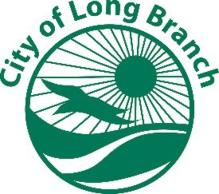
CITY OF LONG BRANCH, MUNICIPAL BUILDING, 344 BROADWAY, LONG BRANCH, N.J. 07740 (732)222-7000

Request for Flood Zone Determination

Date:

Owner: __________________________________________

Address of Property: ________________________________

Lot: _____ Block: ______

Mailing Address:
(if different from above)

Email:
(please indicate if email is acceptable for delivery) Yes No

Fax#:
(if you wish the report faxed to you)

Submit forms to: lneumann@cmeusa1.com

